2. SIGNAL PROPERTIES AND TRANSFORMATIONS
Experiment 2.1
Periodic and Aperiodic Signals
Aim:
To generate and distinguish between periodic and aperiodic signals using MATLAB. The
Aim is to demonstrate the fundamental difference between periodic and aperiodic signals by
creating examples of each and analyzing their properties.
Program:
% Periodic and Aperiodic Signals
clc;
clear;
close all;
% Time axis
t = -5:0.01:5;
% Periodic Signal (Sine Wave)
x1 = sin(2*pi*t);
% Aperiodic Signal (Exponential Decay)
x2 = exp(-abs(t));
% Plotting
figure;
subplot(2,1,1);
plot(t,x1,'LineWidth',2);
grid on;
title('Periodic Signal');
xlabel('Time (s)');
ylabel('Amplitude');
subplot(2,1,2);
plot(t,x2,'LineWidth',2);
grid on;
title('Aperiodic Signal');
xlabel('Time (s)');
ylabel('Amplitude');
Output Waveform:
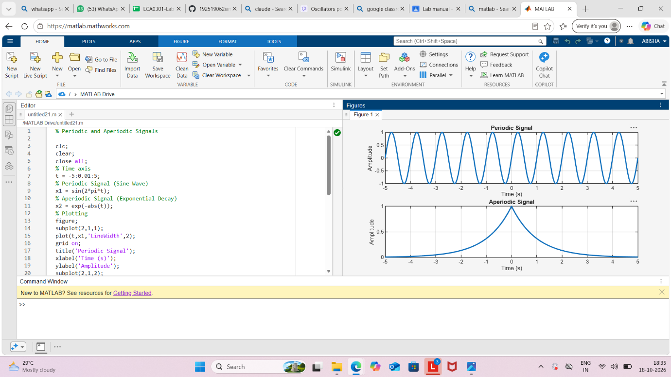
Result:
• Periodic Signal: The sinusoidal signal repeats itself at regular intervals, making it
periodic.
• Aperiodic Signal: The exponentially decaying signal does not repeat, showcasing
that it is aperiodic.
This test case illustrates the key differences between periodic and aperiodic signals by
generating and visually analysing both types using MATLAB.

Experiment 2.2
Verification of Even and Odd Signal Decomposition
Aim
Decompose a signal into even and odd parts and verify reconstruction.
Apparatus Required
PC with MATLAB.
Program (MATLAB)
% Verification of Even and Odd Signal Decomposition
clc;
clear;
close all;
% Time axis
t = -5:0.1:5;
% Original Signal
x = t.^3 + t;
% Time-reversed Signal
x_rev = (-t).^3 + (-t);
% Even Component
xe = (x + x_rev)/2;
% Odd Component
xo = (x - x_rev)/2;
% Reconstruction of Original Signal
x_reconstructed = xe + xo;
% Plotting
figure;
subplot(4,1,1);
plot(t,x,'LineWidth',2);
grid on;
title('Original Signal x(t)');
xlabel('Time');
ylabel('Amplitude');
subplot(4,1,2);
plot(t,xe,'LineWidth',2);
grid on;
title('Even Component x_e(t)');
xlabel('Time');
ylabel('Amplitude');
subplot(4,1,3);
plot(t,xo,'LineWidth',2);
grid on;
title('Odd Component x_o(t)');
xlabel('Time');
ylabel('Amplitude');
subplot(4,1,4);
plot(t,x_reconstructed,'LineWidth',2);
grid on;
title('Reconstructed Signal x_e(t) + x_o(t)');
xlabel('Time');
ylabel('Amplitude');
Output Generated Graph
Original signal plus even (dashed) and odd (dotted) components.
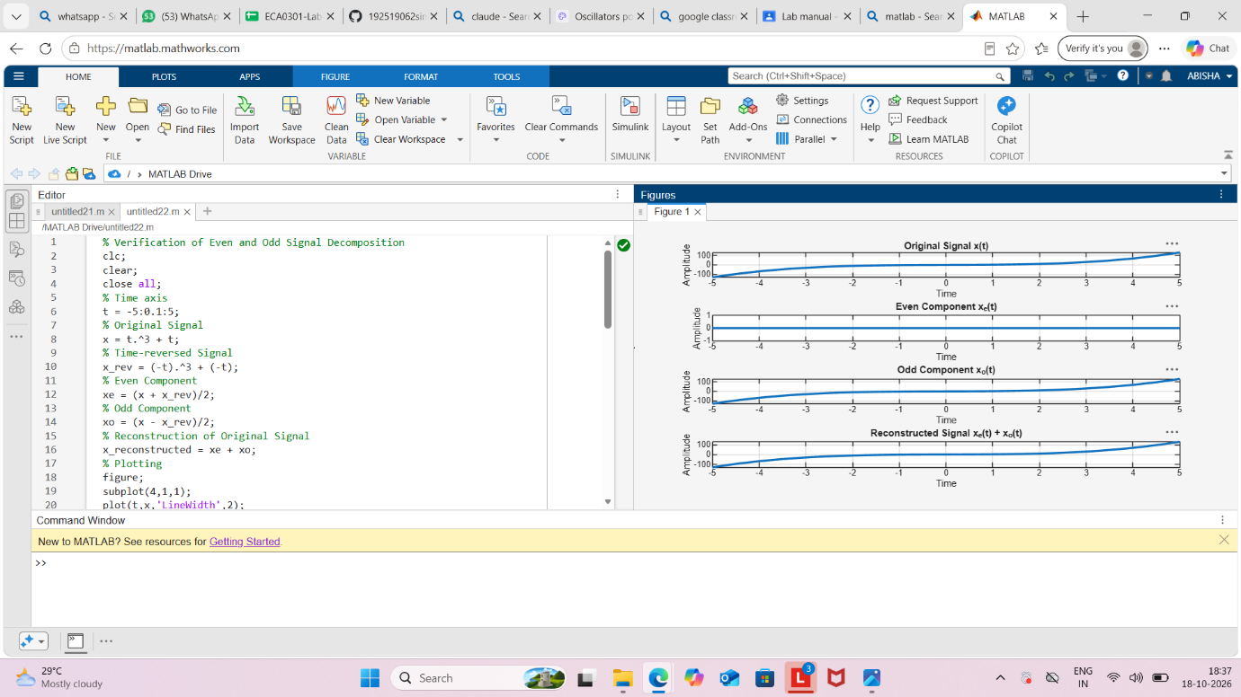

Result
Signal equals sum of even and odd parts.

Experiment 2.3
Amplitude and Time Scaling of Signals
Aim
Demonstrate amplitude and time scaling.
Apparatus Required
PC with MATLAB.
Program (MATLAB)
% Amplitude and Time Scaling of Signals
clc;
clear;
close all;
% Time axis
t = -5:0.01:5;
% Original Signal
x = sin(2*pi*t);
% Amplitude Scaling
x_amp = 2*x;
% Time Scaling (Compression)
x_time = sin(2*pi*2*t);
% Plotting
figure;
subplot(3,1,1);
plot(t,x,'LineWidth',2);
grid on;
title('Original Signal x(t)');
xlabel('Time (s)');
ylabel('Amplitude');
subplot(3,1,2);
plot(t,x_amp,'LineWidth',2);
grid on;
title('Amplitude Scaled Signal 2x(t)');
xlabel('Time (s)');
ylabel('Amplitude');
subplot(3,1,3);
plot(t,x_time,'LineWidth',2);
grid on;
title('Time Scaled Signal x(2t)');
xlabel('Time (s)');
ylabel('Amplitude');
Output Generated Graph
Three plots: original, amplitude-scaled, time-compressed/expanded.
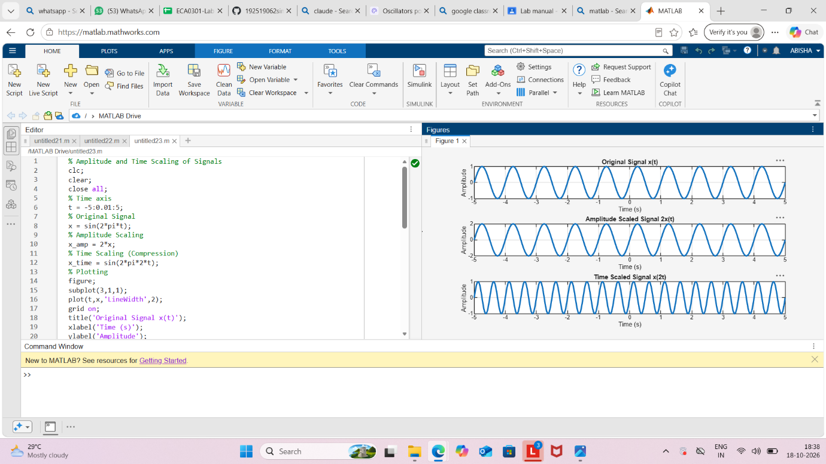

Result
Scaling affects amplitude or time axis accordingly.

Experiment 2.4
Time Shifting and Time Reversal of Signals
Aim
Demonstrate time shift and reversal.
Apparatus Required
PC with MATLAB.
Program (MATLAB)
% Time Shifting and Time Reversal of Signals
clc;
clear;
close all;
% Time axis
t = -5:0.01:5;
% Original Signal
x = sin(2*pi*t);
% Time Shift (Delay by 2 seconds)
x_shift = sin(2*pi*(t-2));
% Time Reversal
x_reverse = sin(2*pi*(-t));
% Plotting
figure;
subplot(3,1,1);
plot(t,x,'LineWidth',2);
grid on;
title('Original Signal x(t)');
xlabel('Time (s)');
ylabel('Amplitude');
subplot(3,1,2);
plot(t,x_shift,'LineWidth',2);
grid on;
title('Time Shifted Signal x(t-2)');
xlabel('Time (s)');
ylabel('Amplitude');
subplot(3,1,3);
plot(t,x_reverse,'LineWidth',2);
grid on;
title('Time Reversed Signal x(-t)');
xlabel('Time (s)');
ylabel('Amplitude');
Output Generated Graph
Original, shifted, and reversed signals.
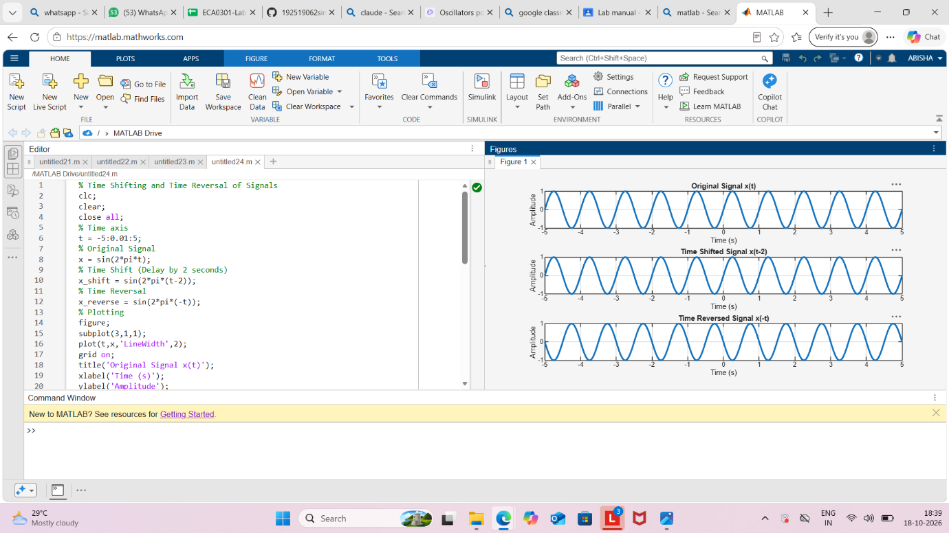

Result
The sinusoidal signal was successfully subjected to time shifting and time reversal using
MATLAB. The time-shifted signal was delayed by 2 seconds, while the time-reversed signal
was obtained by reflecting the original signal about the vertical axis, demonstrating
fundamental signal transformation operations.

